# DSA LAB TASK 4

**NAME:** M. Omerullah Ansari

**STD ID:** 65584

Task 1

def bubble_sort(arr):

n = len(arr)

swaps = 0

for i in range(n):

for j in range(0, n-i-1):

if arr[j] > arr[j+1]:

arr[j], arr[j+1] = arr[j+1], arr[j]

swaps += 1

return arr, swaps

arr = [4, 3, 9, 3, 1]

sorted_arr, swaps = bubble_sort(arr)

print("Sorted Array:", sorted_arr)

print("Total number of swaps:", swaps)

**OUTPUT:**

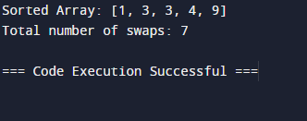

Task 2

def selection_sort(arr):

n = len(arr)

swaps = 0

for i in range(n):

min_index = i

for j in range(i+1, n):

if arr[j] < arr[min_index]:

min_index = j

arr[i], arr[min_index] = arr[min_index], arr[i]

swaps += 1

return arr, swaps

arr = [4, 3, 9, 3, 1]

sorted_arr, swaps = selection_sort(arr)

print("Sorted Array:", sorted_arr)

print("Total number of swaps:", swaps)

**OUTPUT:**

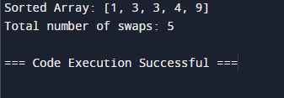

Task 3

def insertion_sort(arr):

n = len(arr)

insertion_count = 0

for i in range(1, n):

key = arr[i]

j = i - 1

while j >= 0 and key < arr[j]:

arr[j + 1] = arr[j]

j -= 1

insertion_count += 1

arr[j + 1] = key

return arr, insertion_count

arr = [4, 3, 9, 3, 1]

sorted_arr, insertions = insertion_sort(arr)

print("Sorted Array:", sorted_arr)

print("Total number of insertions:", insertions)

**OUTPUT:**

~~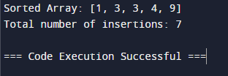~~

Task 4

def sort_even_odd(arr):

evens = [x for x in arr if x % 2 == 0]

odds = [x for x in arr if x % 2 != 0]

evens.sort()

odds.sort(reverse=True)

return evens + odds

arr = [2, 5, 1, 0, 4, 7, 9, 3, -2, 10, 20, 15]

sorted_arr = sort_even_odd(arr)

print("Sorted Array with even numbers in ascending and odd numbers in descending order:", sorted_arr)

**OUTPUT:**

